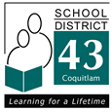
550 Poirier Street, Coquitlam, British Columbia V3J 6A7 • Phone (604) 939 9201 • Fax (604) 939 7828
January 9,2013

INFORMATION FOR PARENTS AND GUARDIANS
Foundation Skills Assessment

School District No. 43 (Coquitlam) is proceeding with district participation in FSA, in accordance with the School Act.

Within the school district, four sources of student assessment data help to inform the decisions of the Board of Education regarding student achievement. Each year, student assessment information is collected from classroom teachers, school assessments, district assessments, and provincial assessments (including FSA and Provincial Exams). These four sources of student assessment data together provide comprehensive evidence of student achievement in Coquitlam School District.

Foundation Skills Assessment measures literacy and numeracy skills set out in provincial curricula. Some facts about FSA:
- FSA is a set of three tests administered to Grade 4 and 7 students that cover specific reading, writing and numeracy skills in provincial curricula
- FSA measures skills students gain over several school years, not only in a single year
- As a provincially prescribed assessment, all Grade 4 and Grade 7 students are expected to participate in the FSA
- There are specific exemptions identified by the Ministry regarding students who have previously written the FSAs at that grade level, some students with IEPs and some students receiving EAL support

A parent/guardian wishing to request that a student be excused from participating in the 2013 FSA can do so under the following exemptions as set out by the Ministry of Education:
- Family emergency
- Illness
- Extenuating circumstances

Please contact your Principal should you need to discuss this information as it pertains to your Grade 4 or Grade 7 child.

For more information on FSAs, visit www.bced.gov.bc.ca/assessment/fsa

Sincerely,
SCHOOL DISTRICT NO. 43 (COQUITLAM)
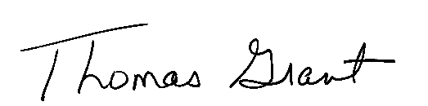
Tom Grant, Superintendent of Schools

C: Board of Education

